***Task 5 (D1)***

***Produce a report of no more than five hundred words which evaluates the interpersonal and written communication techniques that you have used in the previous tasks.***

Communication is where messages are exchanged usually through words, messaging. Communication can be usually done through social networking sites,

Interpersonal skills are the skills we use to communicate and cooperate with other people, both individually and in groups. This means by the ability to communicate with other colleagues and receive information from the other person. The advantage of this is that by speaking effectively, the person can interact with colleagues effectively. For example, if a person was invited to an interview as a professional job. As the person has a lack of interpersonal skills, it would be unsuccessful interview and the opportunity of a job being accepted, would be highly unlikely. Also, it’s the way the person presents himself whilst he is speaking. For example, if he is mumbling whilst he is speaking. It would be difficult for the employer to understand.

[](http://www.google.co.uk/url?sa=i&rct=j&q=&esrc=s&frm=1&source=images&cd=&cad=rja&docid=IDWEEHcYxv0UwM&tbnid=vmMslWeCALz0yM:&ved=0CAUQjRw&url=http://www.trainingontarget.com/mainpages/interpersonal_skills.asp&ei=AzFJUsKlA8OS7Qayp4FY&bvm=bv.53217764,d.ZGU&psig=AFQjCNGx0uKEnE62NSZoUAVWYoI_UmNh-w&ust=1380614707448207)Written communication is how you well you have typed the work. For example, the grammar, punctuation, organisation. This requires good knowledge of English, vocabulary is important as it tests the users knowledge of how well written communication.

They are multiple ways of communication through the internet. Here are some examples:

* ***Email***
* ***Facebook***
* ***Skype***
* ***Twitter***

***How I prepared for it?***

I prepared for P5, P6 and M2 by structuring my work. If my work is all unorganised then it would be confusing. I made it clear, I proof-read my work to identify any mistakes and big/bold. Once I finished the tasks, I proofread my work to identify any mistakes and enhance it. I prepared for the task, P4, by practicing in front of a group of audience on what I was going to say. I stood confident and summarised the points that was made. This was just practice and I got great feedback from the people.

***During the presentation and tasks***

***How it went?***

[](http://www.google.co.uk/url?sa=i&rct=j&q=&esrc=s&frm=1&source=images&cd=&cad=rja&docid=x8o9HCanrB5xbM&tbnid=RuAilSkK_PGwjM:&ved=0CAUQjRw&url=http://www.presentermedia.com/index.php?target=closeup&maincat=clipart&id=2466&ei=XjFJUr77EcXR7Aas6IGQAQ&bvm=bv.53217764,d.ZGU&psig=AFQjCNEMiqd4_0qEUzHZxCHkVceQhfpn6w&ust=1380614857481981)During my presentation, I had to keep interest and get my point across to the audience. So I had to explain to a person that hasn’t used a social networking site before. I appointed what communication meant at the beginning. Secondly I had to explain what Facebook was and how it worked, because they didn’t know anything about it. I had to do this loud and clear. Keeping in mind, the text had to be clear to see to the audience.

Furthermore I summarised, to sum up the most important points of a communication, my presentation for each point. I got asked open and closed questions once my presentation was finished. I answered them loud and clear to justify what had been said.

At my presentation, there was a clear picture of a profile page on Facebook. There was no information on it. I explained how it worked and where statuses was located and how communication works through the statuses. Again, it had to be clear in order for the audience to see what I am doing.

When my partner was identifying and reviewing my mistakes for M2, he spotted some on P5 and told me. We both negotiated to agree that he was correct. He said to make a new slide on, ‘How Facebook works?’ I agreed and I knew he was correct, because too little detail was given about how it works on one slide.

During the presentation, it became a lot clear to me to explain and justify my answer of how Facebook works. I justified my answer, more to that question, and gave it clear answers so the reader can understand. Also, he added another point to my disadvantages for communication on Facebook as we agreed to that as well.

For P6 he spotted a grammatical error, I agreed with it and changed it. The rest was fine. It was clear structured and well analysed information.

This was part of the presentation. I only had this picture on the presentation slide. I had no text beside it and I explained in the presentation how this page works. Facebook is regulary updated for easier communication. For example, before webcam communication was unavaliable, whereas now it has been updated.

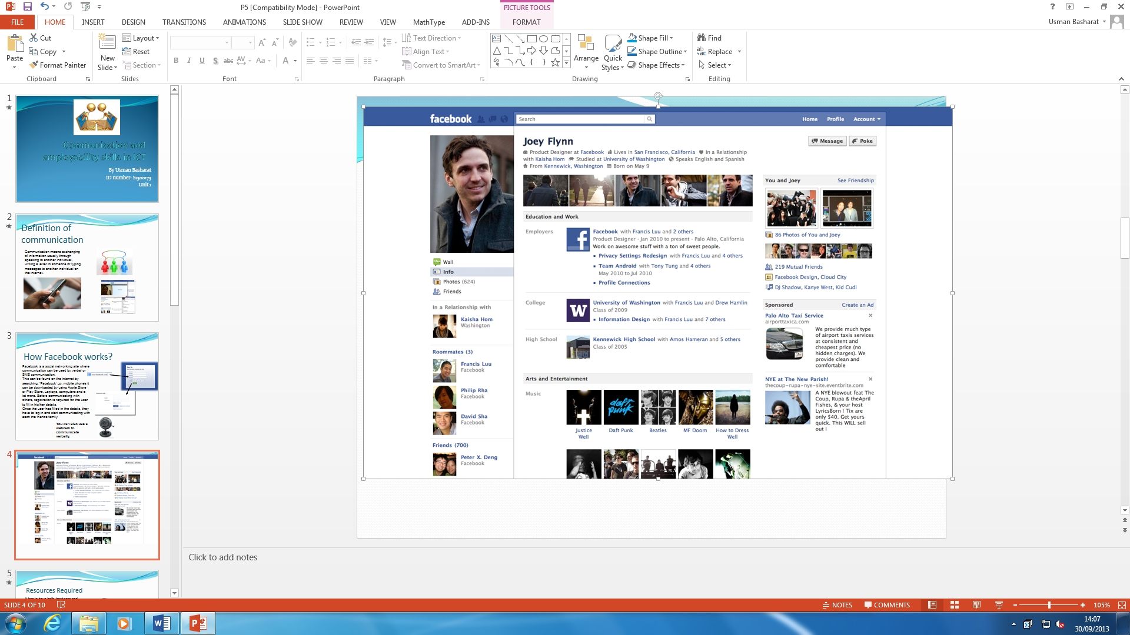

This is where you updated your profile picture.

This information is where all other users of Facebook can see this information.

This is a part where it says ‘Wall’ and all the statuses that the user puts up, others can see

***The skills I developed***

The skills I developed throughout these tasks that were set was built of confidence, because I had to communicate throughout these tasks to my partner that was reviewing my work and the presentation to the teacher. I established how to review a partner’s work. For example, P5 and P6 needed reviewing so I appointed out all the mistakes such as: grammar, punctuation, and organisation/layout of the task. These were reviewed by myself as I improved these key skills as well as developed. I knew how to do this task better. Also, I developed key skills is enhancing my work once I got my reviewed work after my partner reviewed it.

Furthermore, I developed to speak louder and communicate with each a partner and negotiation was clear and agreeable. We both agreed with each other’s reviewed work that the corrections that were made was meant to be enhanced. I enhanced my work, making it better from the feedback I got from my reviewed work.